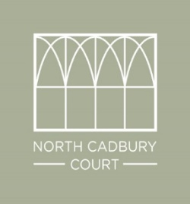

Croupier for North Cadbury Court Casino
Jamie Alexander 07717 362424 jamie@playlearnhire.com

There are 3 casino tables available - these are Blackjack, Roulette and Texas Hold’em Poker.
The tables can be run by professional croupiers and gaming time is for up to 3 hours. Each game is easily taught so they are perfect for all abilities.
At any one time, 8 people can play roulette, 7 can play Blackjack and 10 can play Texas Hold’em, however, there is space for others to watch.
Please note all games are just for fun so no money is exchanged during the event.
Guests are given 'fun money' to play with. We recommend each player starts with 1 note totalling £200. Prizes can be presented to the player who makes the most money.
To organise your casino a £50 booking fee is required, this will also secure the date of your event.
The fee is £120 per croupier, paid directly to each croupier, which includes travel and up to 3 hours' continuous dealing.
In addition to this service other casino games can be added to your event, which include Craps/Dice, 3 Card Poker and Wheel of Fortune.
We also offer a range of themed props which can help to decorate the venue. Themes include Las Vegas, The Great Gatsby and James Bond.

For further information please email jamie@playlearnhire.com with NCC and your chosen date as the subject title

